CSIS-312 Assignment 3 by Victor Canas

# Screen Shots showing program running:

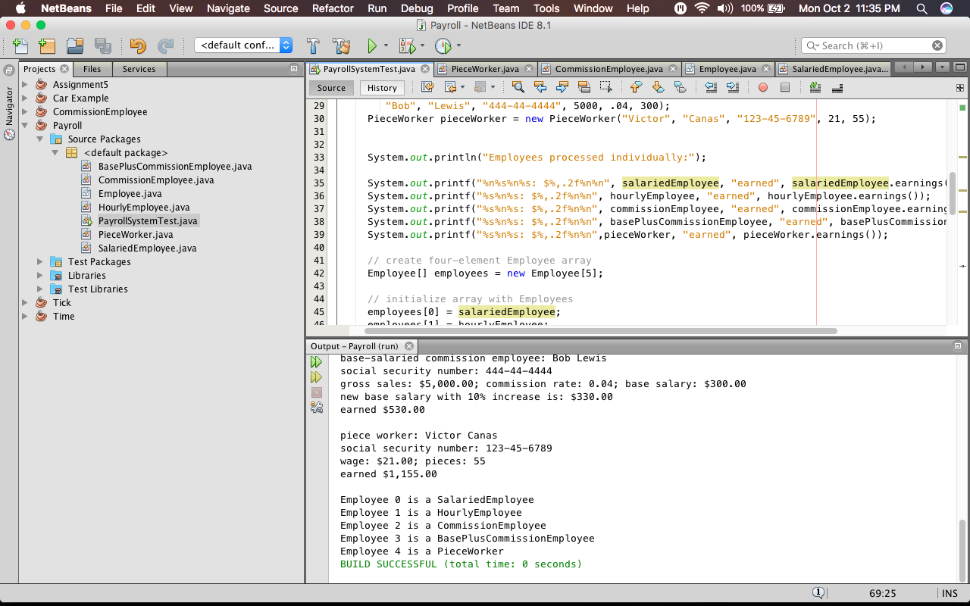

# Integrity Statements:

* + ***I have not shared the source code in my program with anyone other than my instructor’s approved human sources.***
  + ***I have not used source code obtained from another student, or any other unauthorized source, either modified or unmodified.***
  + ***If any source code or documentation used in my program was obtained from another source, such as a text book or course notes, that has been clearly noted with a proper citation in the comments of my program.***
  + ***I have not knowingly designed this program in such a way as to defeat or interfere with the normal operation of any machine it is graded on or to produce apparently correct results when in fact it does not.***